CLOUD COMPUTING BASICS Date: 02-11-2026

1. What is cloud computing?
Cloud computing is the on-demand delivery of IT resources and computing services such as servers, storage, databases, networking, and software over the internet with pay-as-you-go pricing.
- Companies had to purchase physical servers, storage devices, and networking equipment.
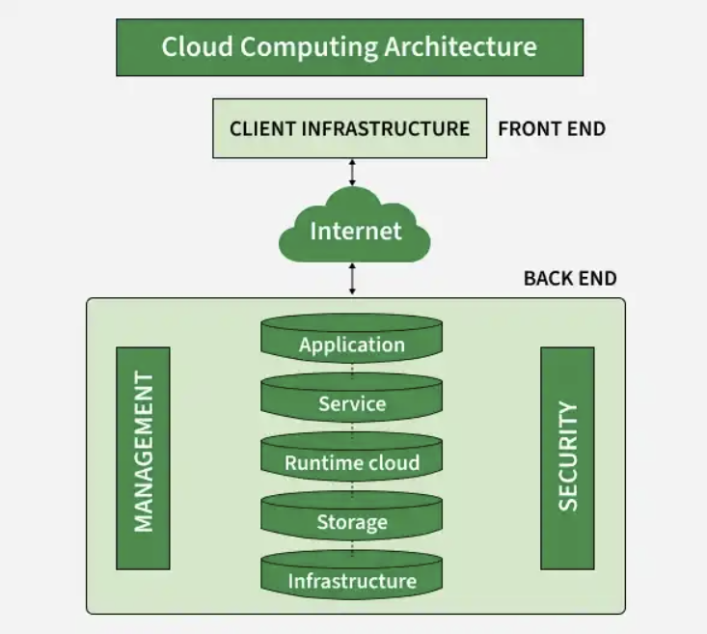
- Hardware is no longer purchased; computing resources are rented from cloud providers such as AWS, Google, or Microsoft.
Cloud Computing Architecture

2.What is Azure cloud?
Azure is a public cloud computing platform developed by Microsoft. It is used to build, test, deploy, and manage applications and services through Microsoft-managed data centers.

Key Things Azure is Used For:
App Hosting and Development Data Storage and Databases
Artificial Intelligence and Machine Learning Disaster Recovery and Backup
Hybrid and Multi-Cloud Operations Security and Identity Management

Azure provides services across four main categories:
IaaS , PaaS , SaaS . Serverless Computing(Run code in response to events without provisioning or managing servers at all)

3. Advantages of cloud computing :
Key Advantages
- Cost Savings & Pay-as-You-Go Model: Replaces large upfront hardware capital expenditures (CapEx) with a flexible operational expenditure (OpEx) model where you pay only for the resources you consume.
- Scalability and Flexibility: Lets you scale compute power or storage up or down instantly to handle traffic spikes or quiet seasons without buying physical servers.
- Global Accessibility and Mobility: Enables teams to access files, applications, and data from anywhere in the world on any internet connected device.
- Improved Collaboration: Establishes a centralized "single source of truth" where multiple people can view and edit shared documents in real time, preventing version control conflicts.
- Automatic Updates and Maintenance: Offloads routine infrastructure upkeep, software patches, and hardware maintenance to the third-party provider.
- Enhanced Security and Backup: Provides enterprise grade features like automated backups, disaster recovery, data encryption, and remote wiping capabilities.
- Faster Time to Market: Allows developers to provision virtual instances and test new applications in minutes rather than waiting weeks for physical hardware procurement.

4. What is Iaas , PaaS , SaaS ?
1. IaaS (Infrastructure as a Service)
The most basic layer. It gives you raw, virtualized computing resources over the internet including virtual servers, storage space, and networking.
- Your responsibility: You manage the operating systems, middleware, applications, and data.
- Provider's responsibility: The vendor manages the physical hardware, data centers, and hypervisors.
- Analogy: Renting an empty building or plot of land where you build and set up everything yourself.
- Examples: Amazon Web Services (AWS) EC2, Google Compute Engine, and Azure Virtual Machines.
- Target Audience: IT Administrators, Network Architects, and DevOps teams.

2. PaaS (Platform as a Service)
A middle layer that provides a complete cloud-based development and deployment environment. It gives developers the tools, databases, and runtime systems needed to build software without worrying about the underlying servers.
- Your responsibility: You manage your custom code and application data.
- Provider's responsibility: The vendor manages the hardware, operating systems, and runtime software/tools.
- Analogy: Renting a fully equipped kitchen with ovens and counters you bring your own ingredients and cook your own meals.
- Examples: Google App Engine, Microsoft Azure App Services, and Heroku.
- Target Audience: Software Developers and Application Delivery Teams.

3. SaaS (Software as a Service)
A fully functional, ready-to-use software application delivered over the web through a browser or app. You just log in and use it.
- Your responsibility: You only manage your own user accounts and data inside the app.
- Provider's responsibility: The vendor manages everything else servers, storage, code, updates, security, and maintenance.
- Analogy: Going to a restaurant or buying a ready-made meal the chef handles everything, and you just eat.
- Examples: Google Gmail, Microsoft 365, Zoom, and Salesforce
- Target Audience: End-users, Business Professionals, and Consumers.

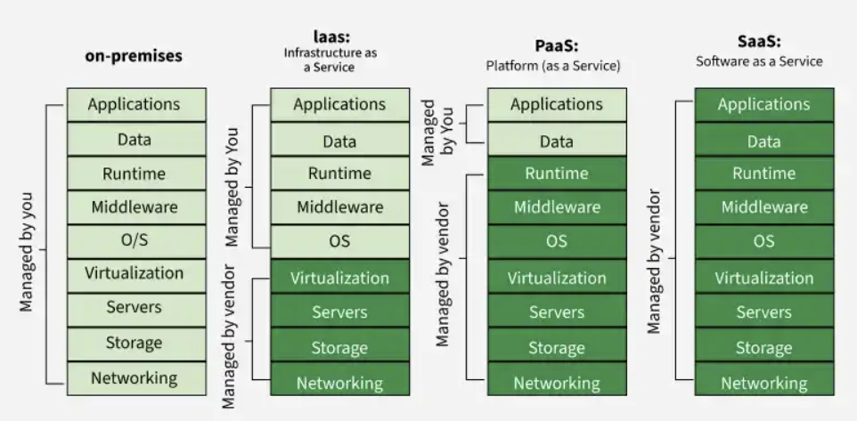

5 . What is Virtual Machines?
A virtual machine (VM) is an isolated computing environment with its own CPU, memory, network interface, and storage, created from a pool of hardware resources.
It is a virtual representation or emulation of a physical computer that uses software instead of hardware to run programs and deploy applications. By using the resources of a single physical machine memory, CPU, network interface and storage VMs enable businesses to run multiple machines virtually (with different operating systems) on a single device.

6. Components of VM:
The main components of a virtual machine include virtual hardware (CPU, memory, storage, network), a hypervisor, a guest operating system, and optional tools such as VMware Tools or snapshots.
Core Components of a Virtual Machine
1. Virtual Hardware
Virtual hardware simulates the physical components of a computer:
- CPU – Provides processing power to the VM.
- Memory (RAM) – Allocated virtual memory for the guest OS and applications.
- Storage (Disk) – Virtual disks store the OS, applications, and data.
- Network Interface – Enables network connectivity.
These components allow the VM to operate like a physical machine.
2. Hypervisor (Virtualization Layer)
The hypervisor manages and allocates physical resources to VMs.
- Type 1 (Bare-metal) – Runs directly on hardware (e.g., VMware ESXi, Hyper-V).
- Type 2 (Hosted) – Runs on top of an OS (e.g., VirtualBox, VMware Workstation).
It ensures isolation, resource sharing, and efficient VM operation
3. Guest Operating System
The OS installed inside the VM (e.g., Windows, Linux, macOS).It functions like an OS on a physical computer and must be maintained and patched.
4. Virtualization Tools (e.g., VMware Tools)
Enhance VM performance and manageability by providing optimized drivers and utilities.
5. Additional Elements
- Snapshots – Save VM state for rollback or testing.
- Live Migration – Move running VMs between hosts without downtime.
- Resource Management – Controls CPU, memory, and storage allocation
7.What is Data Bricks?
Databricks is a cloud-based data analytics platform built on Apache Spark for processing and analyzing large datasets. It provides a unified workspace for data engineering, analytics, and machine learning and integrates with AWS, Azure, and Google Cloud.
Databricks works by combining cloud storage, Apache Spark–based compute, and Delta Lake into a unified “lakehouse” platform where data ingestion, processing, governance, analytics, and machine learning all run in one environment. It separates the control plane (management) from the compute plane (execution), uses Delta Lake for ACID‑compliant storage, and supports collaborative notebooks and automated pipelines.

8. Data Exploration and Visualization in Databricks :
Databricks offers built-in EDA tools in SQL and notebooks, plus rich visualization editors, dashboards, and pre-installed Python libraries to explore data interactively.

9. What is EDA in Data Bricks?
Databricks supports exploratory data analysis through Databricks SQL dashboards, notebook visualizations, and built-in Python libraries such as pandas, NumPy, Matplotlib, and Plotly, enabling you to load, clean, summarize, and visualize datasets directly in notebooks.
EDA Workflow in Databricks
- Load data
  - Use spark.read.table() or import CSV files into the workspace.
  - Convert PySpark DataFrames to pandas for detailed manipulation.
- Clean data
  - Handle missing values, filter rows, and normalize fields.
- Explore data
  - Summary statistics (mean, median, min/max).
  - Group-by aggregations using SQL or pandas.
- Visualize trends
  - Time-series plots, histograms, scatter plots.
  - Interactive charts using Plotly or built-in notebook visualizations.
- Identify patterns
  - Seasonal trends, correlations, anomalies.
  - Example: analyzing rental patterns over years and seasons.

